Preface

This system falls under the category of operational management regulations.
This system was proposed by the Quality and Safety Department and was drafted with the participation of the Quality and Safety Department.
This system shall be interpreted by the Quality and Safety Department.

Management Procedure of Tooling Acceptance
1 Scope
This management procedure specifies the acceptance requirements of fabricated, reworked and periodical inspection process equipment (hereinafter referred to as tooling), the management of unqualified tooling .
This management procedure is applicable to commercial aircraft production.
This management procedure is developed according to the requirements of GLG1407、D33200-1 and M1194.
2 Normative Reference Documents
The following documents are essential for the application of this document. For all referenced documents marked with a date or (and) version, only the version marked with a date or (and) version is applicable to this document. For any referenced document without a date or (and) version, the latest version (including all modifications) shall apply to this document.

No. | Name | Classification | Document Type | Release time
D33200-1 | Boeing Supplier's Tooling | Public | Customer Specification | None
M1194 | Method for Special Tooling Management in the Supply Chain | Public | Customer Specification | None
GLG1407 | Management Regulation for Tooling and Tools | Public | Management Regulation | None
GLC231008 | Management Procedure for Quality Records | None | Management Procedure | None
3 Form
3.1 Prescribed Form
FM1407-06 Tooling Certificate(see attachment 1)
FM1407-07 Tooling Forbiddance(see attachment 2)
FM1407-08 Tooling Rejection Sheet(see attachment 3)
FM1407-09 Tooling QA Record(see attachment 4)
FM1407-38 Evaluation Sheet of Non-Conforming Tooling(see attachment 5)
FM1407-68 Tooling Acceptance Application Sheet(see attachment 6)
FM1407-70 Nonconformance Tooling Notification(see attachment 7)
3.2 Referenced Form
FM1407-10 Test Equipment Certificate
FM1407-11 Certificate for Tooling
FM1407-16 Record for Tooling Periodical Inspection/Repair
FM1407-33 Tooling Periodical Inspection Technical Requirement
FM1407-55 Application Sheet of Tooling Rework

4 Terms and Definitions

None

5 Organization and Responsibilities
5.1 Technological Innovation Department
a）Technicians in the Tooling Office are responsible for organizing the acceptance of new, repaired, and regularly inspected tooling delivered by tooling suppliers.
b）The inspection personnel in the Tooling Office are responsible for accepting and delivering the newly manufactured tooling owned by our company to SAC/suppliers for use.
c）The designer of the Tooling Design Office is responsible for proposing disposal suggestions for non-conforming tooling found during the acceptance process
5.2 Tooling User
The tooling user inspector is responsible for the acceptance of tooling.
6 Requirements
6.1 Compliance management requirements

Compliance Name | Compliance Type | Classification
《AS9100D Quality Management System - Requirements for Aviation, Aerospace, and Defense Organizations》 | Quality Management | None

6.2 Requirements for Tooling Acceptance Management
6.2.1 Tooling Office technician organizes delivery personnel to confirm if the tooling meet the acceptance conditions, the inspector of the tooling shall be organized on site to inspect the tooling and delivery documents. For the tooling with customer inspection points, Tooling Office technician coordinates with customers to complete the inspection of tooling objects and records. The tooling for programs below shall be accepted by customer tooling representative prior to first use. For other program, see management instruction of this management procedure.
(1) For Boeing program except for B787 program, new, relocated, reactivated, or modified category I and II tools shall be accepted by customer tooling representative, See D33200-1 for detail.
(2) For Airbus program, the tooling that customer accept design shall be accepted by customer tooling representative. See M1194 for detail.
6.2.2 The tooling user shall accept the tooling according to the tooling drawings, FM1407-33, FM1407-55 and other documents.
6.2.3 Tooling acceptance shall include but not limited to the following requirements:
6.2.3.1 Tooling Hardware
(1) The tooling shall be free of damage, missing parts and obvious corrosion.
(2) The tooling label and identification shall meet the requirements of GLB130304-05.
(3) Tooling profile roughness satisfy the specification in tooling drawing.
6.2.3.2 Delivery Documents
(1) The completeness and accuracy of the contents in the delivery documents shall be ensured.
(2) The delivery documents include the following contents.
a) Tooling Certificate
For newly-made tooling, FM1407-06 is used for the qualification certificate of template and non periodic inspection tooling; FM1407-11 shall be used for the qualification certificate of tooling to be inspected periodically; FM1407-10 is used for qualification certificate of test equipment.
For repair, periodic inspection and relocated tooling, repair / periodic inspection/ relocation record shall be filled in the maintenance record of tooling certificate and sealed with inspection stamp.
b) The following conventional measurements shall be recorded in FM 1407-09.
Use measuring tools to measure positioning pin, positioning hole, drilling die hole and other dimensions with tolerance requirements. If the locating pin and bushing of tooling are standard parts, the certificate of standard parts can replace the measurement records. The certificate of standard parts should at least include the specification, quantity and inspection stamp of standard parts;
Install tooling parts according to master tooling. For tooling parts and components installed per master tooling, plug sheets specified in drawing should be used, inspection pins which diameter are accepted should be rotated flexibly. The temperature during using master tooling should be maintained between 17.7℃ to 25.5℃.
Use optical level/theodolite to measure the level and vertical of tooling.
c) If digital measuring equipment is used to measure dimensions with tolerance requirements such as profile and hole position, digital measurement records shall be provided, which shall at least include: Tooling drawing number, Name, Tooling Version, Part Number (When measuring parts), Tooling MBD Number and Version (Applicable to using model to measure tooling for Boeing program, the digital model number shall include the extension), Dispatch Number, Measurement Date, Serial Number, Name of datum and Measurement Point, Theoretical Value(Including XYZ), Tolerance, Actual Value(Including XYZ), Deviation, The Measurement Diagram of Profile and Hole Position, The Description of Temperature, Coordinate System and Measurement Content of The Measuring Part, and The Inspection Stamp. The requirements of laser tracker report see GLB14080302-06. For measurement of tooling ball in periodical inspection, in addition to the laser tracker report, periodic inspection records of tooling shall be provided for B777 program, and FM 1407-16 shall be provided for other programs.
d) If the tooling drawing has provisions on heat treatment, surface treatment and stress relief, corresponding inspection records shall be provided, which shall at least include tooling Drawing Number, Part Number, Work Number, Applicable Serial Number, Process Description, Inspection Stamp and Date.
e) For lifting tooling, load test report shall be provided. For lifting tooling with critical welding area in Boeing program, NDT test report shall also be provided. The report shall at least include Tooling Drawing Number, Test Data, Test Results, Work Number, Applicable Serial Number, Inspection Stamp / Signature and Date.
f) For composite tooling with air tightness requirements, air tightness test report shall be provided. The report shall at least include Tooling Drawing Number, Test Data, Test Results, Work Number, Applicable Serial Number, Inspection Stamp and Date.
g) FM1407-68 is delivered with tooling certificate and above record.
h) For delivery files of duplicated tooling, the unit information shall be contained in delivery files, such as "The second unit XXX tooling" or "XXX tooling(Unit 2)".
6.2.3.3 The acceptance personnel of tooling shall supervise and inspect the manufacturing, measurement of tooling. The requirements of tooling inspection and measurement as blow.
(1) For the features with tolerance which are noted in tooling drawing or file, proper measuring tool or device should be used to complete measurement. The maximum allowable error of measuring tool or device should not exceed 1/4 of tolerance of feature to be measured.
(2) For trials that are specified in tooling drawing or relevant files should be completed per specified parameters.
(3) For tooling parts and components installed per master tooling, plug sheets specified in drawing should be used, inspection pins which diameter are accepted should be rotated flexibly. The temperature during using master tooling should be maintained between 17.7℃ to 25.5℃.
(4) For tooling level and plumb measured by theodolite, theodolite should be set properly per handling specification.
(5) Before inspecting and measuring detachable tooling parts or components, the interface should be without rag and FOD.
(6) When the measurement unit is "inch", the measurement shall be accurate to 4 decimal places. Where the unit of measurement is "mm", the measurement shall be accurate to 3 decimal places. When the measurement unit is "deg", the measurement shall be accurate to 3 decimal places. The temperature (℃ or ℉) applied during measurement shall be accurate to 1 decimal place.
6.2.4 Management of Unqualified Tooling
6.2.4.1 If one of the following conditions occurs in the tooling, it is the unqualified tooling:
a) The periodic inspection validity period has exceeded the specified;
b) Damaged or missing of tooling label /identification;
c) The parts are damaged, rusted or their integrity has been damaged;
d) The function does not meet the use requirements;
e) Damage to the protective device;
f) The tooling characteristics are not in conformity with the valid drawings or technical documents.
g) Unqualified tooling for verification.
6.2.4.2 The non-conforming tooling shall be identified immediately. Fill in FM1407-07 by inspector in Quality Engineering Office of the tooling user, and stick FM1407-07 on the tooling to indicate that it is forbidden to use. Transfer non-conforming tooling into MRCC or separate area to prevent misuse. After the tooling is disposed, it will be removed by inspector in Quality Engineering Office of the tooling user.
6.2.4.3 For the nonconforming tooling found in the process of tooling acceptance, tooling inspector in Quality Engineering Office of the tooling user shall fill in FM1407-70 and feed back the nonconforming tooling to the tooling supplier.
6.2.4.4 Designer in Tooling Design Office receives FM 1407-08 and propose disposition opinion. For the disposal of class I and II nonconforming tooling of Boeing program accepted as is, it is necessary to submit it to Boeing tooling designer by designer in Tooling Design Office, and the nonconforming tooling can be accepted as is after Boeing tooling designer approval.
6.2.4.5 Nonconforming tooling that has not been disposed or without disposition is not allowed to be handed over for inspection.
6.3.4.6 For unqualified tooling during using tooling, application for configuration change, rework, repair, scrap, replenished manufacture shall be done per GLC14070201 / GLC14070303.
6.2.4.7 When the tooling user finds that the size or other characteristic of the used tooling is nonconforming, it is necessary to evaluate whether the use of nonconforming tooling affects the product assembly, manufacturing or inspection results. The planner in Technical Office of the tooling user fills in the evaluation conclusion in FM1407-38, and technician in Tooling Office fills in the comments. When the nonconforming tooling will not affect the products, it is not necessary to trace the relevant products. Otherwise, inspector in Quality Engineering Office of the tooling user fills in the products to be traced in FM1407-38, and the tooling user reports FM1407-38 to Quality & Safety Department, disposition shall be performed per GLC14080401.

7 Process

7.1 Management Process for Tooling Acceptance
7.1.1 Process Chart for Tooling Acceptance Management
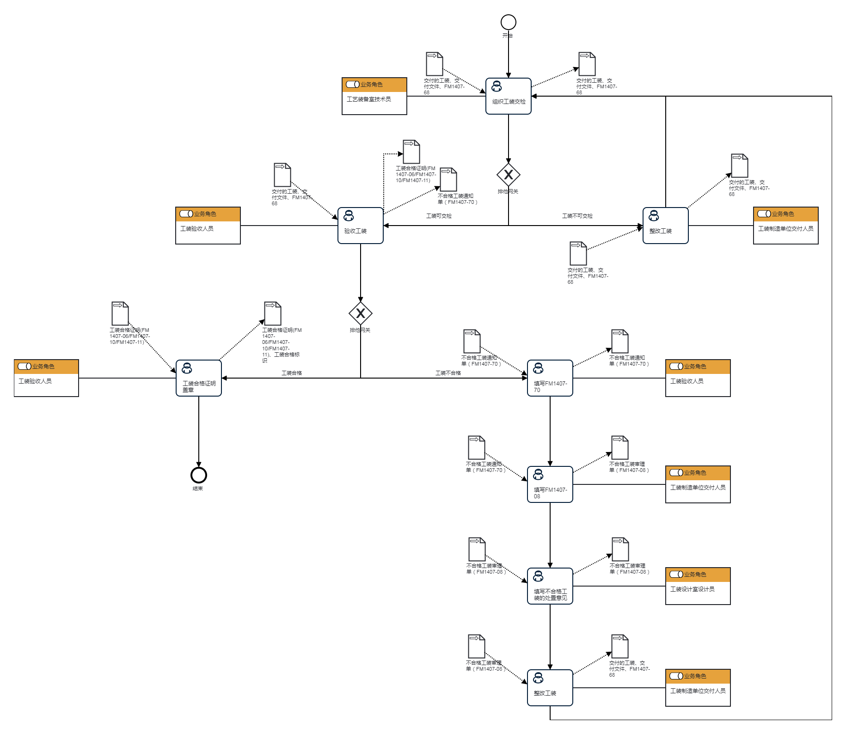
End
Delivery personnel of tooling manufacturing units
Delivered tooling, delivered documents, FM1407-68
Unqualified Tooling Review Form（FM1407-08）
Rectification Tooling
Tooling and Tool Designers
Unqualified Tooling Review Form（FM1407-08）
Unqualified Tooling Review Form（FM1407-08）
Fill in the disposal opinions for unqualified tooling
Delivery personnel of tooling manufacturing units
Unqualified Tooling Review Form（FM1407-08）
Notice of Unqualified Tooling（FM1407-70）
Fill in FM1407-08
Tooling Acceptance Personnel
Notice of Unqualified Tooling（FM1407-70）
Notice of Unqualified Tooling（FM1407-70）
Fill in FM1407-70
Tooling not Accept
Tooling Accept
Tooling Inspect
Tooling not Inspect
Certificate of Qualification for Tooling (FM1407-06/FM1407-10/FM1407-11)
Certificate of Qualification for Tooling (FM1407-06/FM1407-10/FM1407-11)
Tooling Acceptance Personnel
Stamp tooling qualification certificate
Delivery personnel of tooling manufacturing units
Delivered tooling, delivered documents, FM1407-68
Delivered tooling, delivered documents, FM1407-68
Notice of Unqualified Tooling（FM1407-70）
Rectification Tooling
Delivered tooling, delivered documents, FM1407-68
Delivered tooling, delivered documents, FM1407-68
Tooling Acceptance Personnel
Acceptance Tooling
Delivered tooling, delivered documents, FM1407-68
Organize Tooling Inspection
Delivered tooling, delivered documents, FM1407-68
Technician in the Tooling Office
Start

7.1.2 Explanation of Tooling Acceptance Management Process
（1）Organize Tooling Inspection
Organize Tooling Inspection | Step Description | Receive FM1407-68, organize the tooling delivery personnel to confirm that the tooling meets the inspection conditions, and organize acceptance of the tooling for inspection.
 | Activity Frequency | 1 Day
 | Process Role | Technician in the Tooling Office | Post | None
 | Input | Delivered tooling, delivered documents, FM1407-68 | Output | Delivered tooling, delivered documents, FM1407-68
 | Compliance Clauses | None
 | Work Execution Standards | None
 | Risk and Response Measures | None

（2）Acceptance Tooling
Acceptance Tooling | Step Description | Inspect the tooling and determine whether the physical tooling and delivery documents are qualified.
 | Activity Frequency | 1 Day
 | Process Role | Tooling Acceptance Personnel | Post | None
 | Input | Delivered tooling, delivered documents, FM1407-68 | Output | Notice of Unqualified Tooling（FM1407-70）Certificate of Qualification for Tooling (FM1407-06/FM1407-10/FM1407-11)
 | Compliance Clauses | None
 | Work Execution Standards | None
 | Risk and Response Measures | None

（3）Rectification Tooling
Rectification Tooling | Step Description | Rectify the tooling and deliver it again.
 | Activity Frequency | 7 Days
 | Process Role | Delivery personnel of tooling manufacturing units | Post | None
 | Input | Delivered tooling, delivered documents, FM1407-68 | Output | Delivered tooling, delivered documents, FM1407-68
 | Compliance Clauses | None
 | Work Execution Standards | None
 | Risk and Response Measures | None

（4）Stamp tooling qualification certificate
Stamp tooling qualification certificate | Step Description | Stamp and date the tooling qualification certificate (FM1407-06/FM1407-10/FM1407-11), and receive the tooling delivery documents. Seal and inspect according to the management standards for tooling signage identification.
 | Activity Frequency | 1 Hour
 | Process Role | Tooling Acceptance Personnel | Post | None
 | Input | Certificate of Qualification for Tooling (FM1407-06/FM1407-10/FM1407-11) | Output | Certificate of Qualification for Tooling (FM1407-06/FM1407-10/FM1407-11)、Qualified identification of tooling
 | Compliance Clauses | None
 | Work Execution Standards | None
 | Risk and Response Measures | None
（5）Fill in FM1407-70
Fill in FM1407-70 | Step Description | Fill out the Non Conforming Tooling Notice (FM1407-70) and identify the non-conforming tooling.
 | Activity Frequency | 1 Hour
 | Process Role | Tooling Acceptance Personnel | Post | None
 | Input | Notice of Unqualified Tooling（FM1407-70） | Output | Notice of Unqualified Tooling（FM1407-70）
 | Compliance Clauses | None
 | Work Execution Standards | None
 | Risk and Response Measures | None

（6）Fill in FM1407-08
Fill in FM1407-08 | Step Description | Fill in the non conformance information to FM1407-08 according to FM1407-70.
 | Activity Frequency | 1 Hour
 | Process Role | Delivery personnel of tooling manufacturing units | Post | None
 | Input | Notice of Unqualified Tooling（FM1407-70） | Output | Unqualified Tooling Review Form（FM1407-08）
 | Compliance Clauses | None
 | Work Execution Standards | None
 | Risk and Response Measures | None

（7）Fill in the disposal opinions for unqualified tooling
Fill in the disposal opinions for unqualified tooling | Step Description | Fill in the disposal opinions for non-conforming tooling in FM1407-08.
 | Activity Frequency | 4 Hours
 | Process Role | Tooling and Tool Designers | Post | None
 | Input | Unqualified Tooling Review Form（FM1407-08） | Output | Unqualified Tooling Review Form（FM1407-08）
 | Compliance Clauses | None
 | Work Execution Standards | None
 | Risk and Response Measures | None

（8）Rectification tooling
Rectification tooling | Step Description | Rectify the tooling and deliver it again.
 | Activity Frequency | 7 Days
 | Process Role | Delivery personnel of tooling manufacturing units | Post | None
 | Input | Unqualified Tooling Review Form（FM1407-08） | Output | Delivered tooling, delivered documents, FM1407-68
 | Compliance Clauses | None
 | Work Execution Standards | None
 | Risk and Response Measures | None

8 Process role responsibilities
Role Name | Responsibility
Technician in the Tooling Office | Organize the acceptance of new, repaired, and regularly inspected tooling delivered by tooling suppliers.
Designer in the Tooling Design Office | Provide disposal suggestions for non-conforming fixtures found during the acceptance process.
Inspection personnel in the Tooling Office | The property rights of the newly manufactured tooling used by SAC/suppliers for acceptance and delivery belong to our company.
Inspection personnel of the Tooling User | Acceptance of tooling used by own unit.

9 Process Performance Indicator Table
Indicator Name | Qualified Rate of Tooling Acceptance
Set Purpose | None
Indicator Definition | Qualified Rate of Tooling Acceptance
Calculation Formula | Qualified rate of tooling acceptance=number of accepted tooling/total number of completed tooling acceptance
Data Source | None
Statistical Period | Quarter
Statistical Caliber | Offline Collection
Statistical Department | None
Instructions | None

10 Following management instruction are established to support this management procedure
No. | Name | Classification | Instructions
GLB14070204-01 | Acceptance Management Instruction of Tooling for MA700 Program | Public | None
GLB14070204-02 | Acceptance Management Instruction of Tooling for COMAC Program | Public | None
GLB130304-05 | Management Instruction on Tooling Tag and Identification | Public | None
GLB14080302-06 | Management Instruction for Laser Tracker Measurement | Public | None
11 Record Control

11.1 The filling and preservation of relevant records is performed according to GLC231008.
11.2 Tooling delivery files, FM1407-06，FM1407-10, FM1407-11，FM1407-38，FM1407-68 and FM 1407-08 disposed with use as it is are preserved by Tooling User.
11.3 The files fabricated tooling that is owned to our company and delivered to SAC/supplier are preserved by Tooling Office.

